Betting software
- BETFAIR FANCY
- CRICKET
- FOOTBALL
- OTHER SPORTS IF AVAILABLE
- CASH OUT

ADMIN
- ALL MATCH FROM API- api odds , fancy etc
- All match from api sorted by league name- per league after a new page
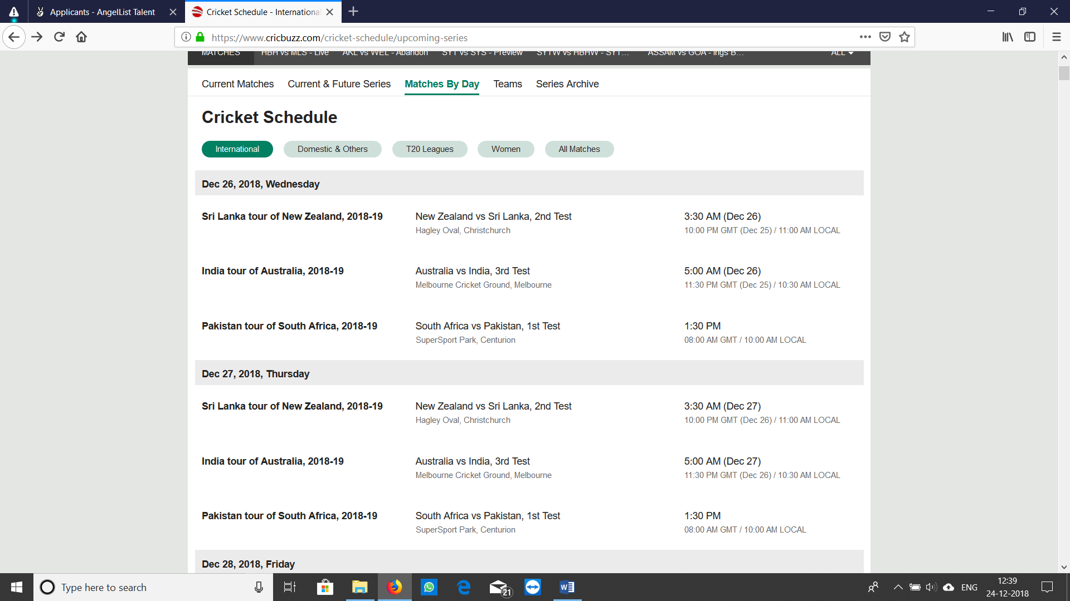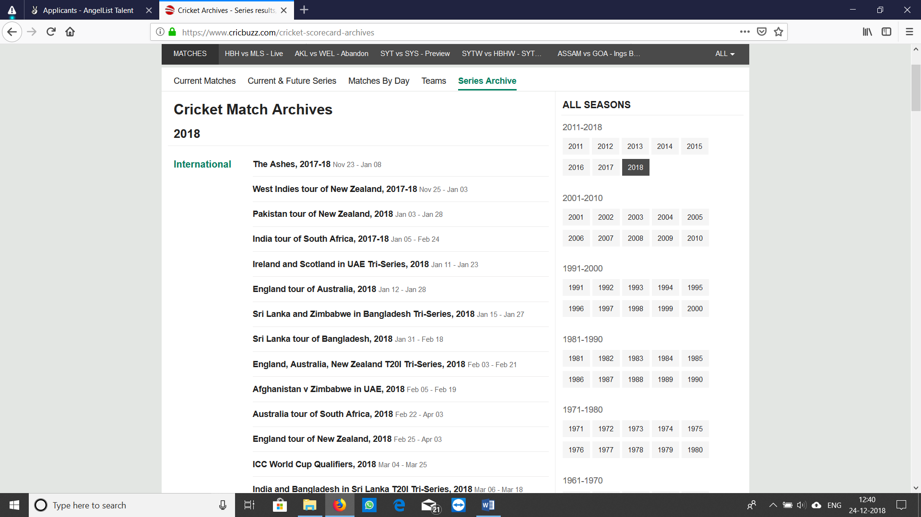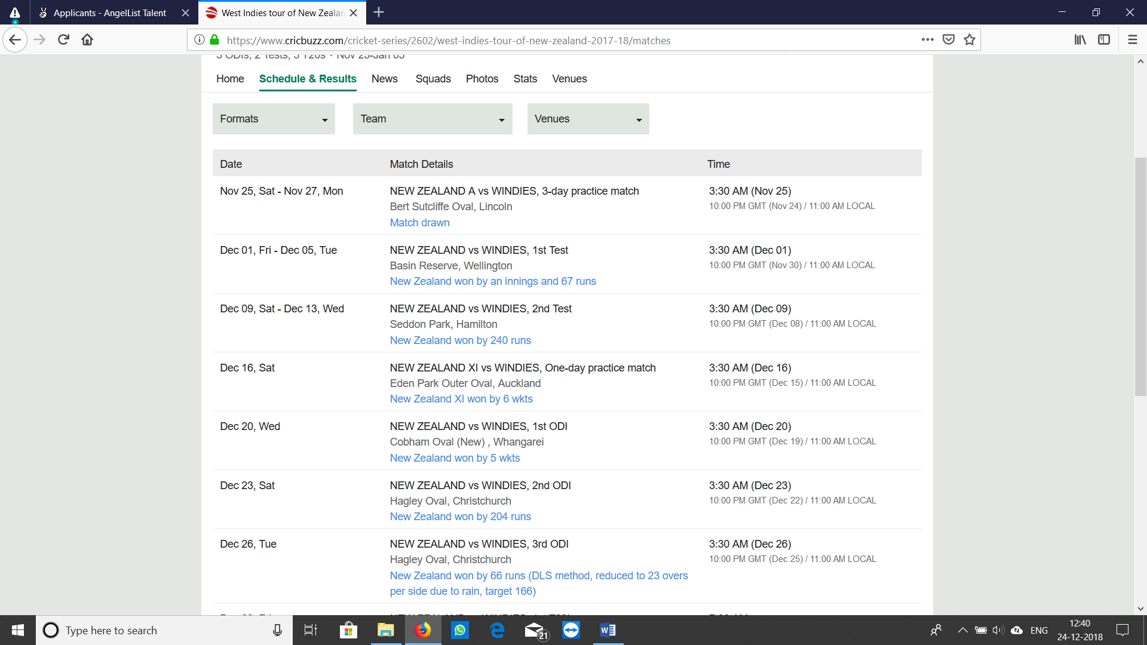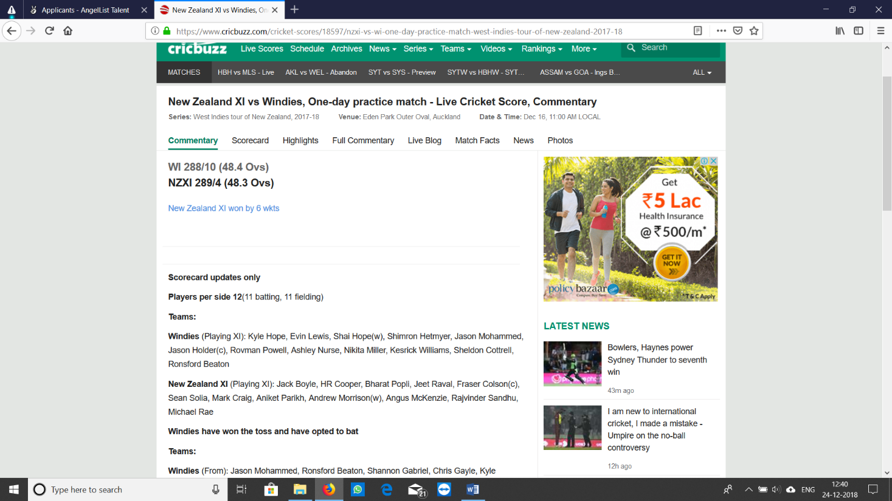

- match activate / deactivate option
per match to user/ and all panel. Only admin rights

- fancy activate/deactive option
only admin rights
- odds and fancy bet allowed option
only show but placing not allowed, admin right only
- all bet delete modify rights
bet placed but if admin wants to remove it or not
- all bet show by smdl/mdl/dl/user
ADMIN>SMDL>MDL>DL>USER
- ip adress of bet device collect, IP address to be tracked by admin
multi user of smdl,mdl,dl,user
- manually result option

- coin transfer / coin reverse
cricket- dounle check once sending coins to a user
galat hua toh wapis kr sake admin se….toh reverse bhi kr sake coins ko
- if any match abondan then their should be option for session settalment which has to be settal and which has to be reverse.
If rain ajati hai nd 20 over k match me 6 over hog ye ho, nd agr kisi ne betting 15th over pr place ki ho toh wo automatically cancel ho jae nd coin reverse ho jae user pe.

- same case in match also if abandon
same point as 15th
- Session / match result edit or update after updation after coin transfer and coin needs to be settal as per new result
Results should be manual/ automatic

- all match toss option, betfair not giving all match toss manually we can set.
Betting on toss also manually
Match start hone se 1 ghante pehle toss betting band ho jae
Toss rate- 1.97
- creation of SMDL user/dl/md
if creating user/dl/mdl, then they upper ld
for ex- if admin is making an id for DL then he needs reference id of smdl and mdl, cannot make direct

- coins for users unlimited to admin
coin distribution to user unlimited from admin
- match book + session book + toss book = total
access to smdl,mdl,dl
smdl ko pta chale ke usne per match kya earning ki hai..

- coin credit to any user,smdl,mdl,dl
- activate deactive SMDL/MDL/DL/user
- active and deactive client total number
if mdl is deactivate then usk dl,user, all gets deactivate
- chip summery – client in profit and loss
admin ne 100 coin generate kie nd 10 coins smdl ko die to uska histry page bane
- profit loss report sport wise and date wise
per game total earning and loss admin
- session book
all user bet placed per smdl/mdl/dl
screenshot in whatsapp with note(point 28/29)
- user account delete rights to SMDL/MDL/DL on off option
user id delete to everyone but after deciding by admin
sometimes on sometimes off

SMDL
- creation of MDL/dl/user

- all match book live
screenshot in whatsapp with note(point 28/29)
- Book sharing system (DL<Master<SMaster<SADMIN—Admin—Company:---Super duper admin)
- show seprate book for sharing book
- match book + session book + toss book = total
- activate deactive MDL/DL/user
- active and deactive client total number
- live match section with number of bets
- chip summery – client in profit and loss
- profit loss report sport wise and date wise
- session book
- unmatch bet option to see unmatch bet
if runrate change bet place na ho, coin cut naho and bet unmatch bet page pr ajae
- match book with all bets
- account statment – loss profit each match

MDL
- creation of DL sharing / without sharing
- match book + session book + toss book = total
- active and deactive client total number
- live match section with number of bets
- in play match
if match starts then in should be showed in inplay
- my market
users all matches in which he placed bet should be shown in one place
- chip summery – client in profit and loss
- account statment
- account statment – loss profit each match
- Book sharing system (DL<MDL<SDML<ADMIN)
Profit/loss sharing with admin

DL
- match activate / deactivate option
- sesion fancy activate / deactivate option
- in play match
- my market
- match book + session book + toss book = total
- active and deactive client total number
- live match section with number of bets
- chip summery – client in profit and loss
- profit loss report sport wise and date wise
- session book
- unmatch bet option to see unmatch bet
- match book with all bets
- account statment – loss profit each match
- user statment seprate for match toss session
- coin credit debit to user
- session comission – 2 types will discuss on call for more details with vaibhav sir
- match comisson
- Exposer – amount which punter bet on live match

USER DASHBOARD – live match
- My market – match which user bet
- ALL MATCH
- Diffrent tabs for all games
- bet history match wise and chips wise
www.diamondexch.in user- 001sbgdemo pass-12345
- profit loss report sport, match, day, fancy, toss seprate
- password change
- exposer
- total balance
- live video
- score with commentry
- unmatch bet
- Bet calculator

